**Assignment 1:**

Part 1:

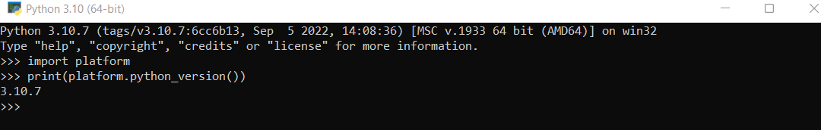

Part 2:

Python Output:

